**Assignment/Tutorial/Practical Report Cover Sheet**

|  |
| --- |
| Student’s Name :   1. CHAI MIN CHUN 35657 2. CHOO TING WEI 35769 3. LAI TED LIANG 36579 4. LIM BAN YONG 36709 5. WILLIS FUNG SHIN CHOI 39324 |

|  |  |
| --- | --- |
| Subject Code :TMP3413 | Subject Name : Software Engineering Laboratory |

|  |  |
| --- | --- |
| Assignment/Tutorial/Practical Number of Title : | Project Proposal |

|  |  |
| --- | --- |
| Name of Lecturer : | Mdm. Nurfauza Jali |

|  |  |
| --- | --- |
| Due Date : 10 October 2014 | Date Submitted : 10 October 2014 |

This cover sheet must be completed, signed and firmly attached to the front of the submission.

All work must be submitted by the due date. If an extension of work is granted, an assignment extension acknowledgement slip must be signed by the lecturer/tutor and attached to assignment.

Please note that is your responsibility to retain copies of your assignment.

|  |
| --- |
| ***Plagiarism and Collusion are methods of cheating that falls under Peraturan Akademik Universiti Malaysia Sarawak para 11: Etika Akademik***  **Plagiarism**  Plagiarism is the presentation of work which has been copied in whole or in part from another person’s work, or from any other source such as the internet, published books or periodicals without due acknowledgement given in the text.  **Collusion**  Collusion is the presentation of work that is the result in whole or in part of unauthorized collaboration with another person or persons.  Where there are reasonable grounds for believing that cheating has occurred, the only action that may be taken when plagiarism or collusion is detected is for the staff member not to mark the item of work and to report or refer the matter to the Dean. This may result in work being disallowed and given a fail grade or if the circumstances warrant, the matter may be referred to a Committee of inquiry for investigation. Such investigation may result in the matter being referred to the University Discipline Committee, **which** has the power to exclude a student. |

|  |
| --- |
| **MARK :** |

**Project Title:**

**Life Tree**

**Team Name:**

**D2D**

**Members**

**35657 Chai Min Chun**

**35769 Choo Ting Wei**

**36579 Lai Ted Liang**

**36709 Lim Ban Yong**

**39324 Willis Fung Shin Choi**

**Table of Content**

**Page No.**

**Abstract ---------------------------------------------------------- 1**

**Background Study ---------------------------------------------------------- 2 - 3**

**Problem Statement ---------------------------------------------------------- 3**

**Objective ---------------------------------------------------------- 3**

**Scope ---------------------------------------------------------- 4**

**Task Allocation ---------------------------------------------------------- 4**

**Project Goal ---------------------------------------------------------- 4**

**Team Goal ---------------------------------------------------------- 4**

**Team Contribution ---------------------------------------------------------- 5**

**Expected result ---------------------------------------------------------- 6**

**Checklist ---------------------------------------------------------- 6**

**Project Planning ---------------------------------------------------------- 7**

**TSP Student Information Sheet ---------------------------------------------------------- 8 - 17**

**References ---------------------------------------------------------- 18**

**Abstract**

Pollution has been an issue worldwide since beginning of time. Pollution can take form of chemical substances or energy. Pollution is mainly caused by human activities although it can be caused by other factors. The effect of pollution is contamination into the natural environment and most importantly effects human health. Some contamination are so severe that caused several places inhabitable. For example, the nuclear disaster in Chernobyl has made it inhabitable for us to live in due to high nuclear radiation (Chernobyl Accident 1986, n.d.). Few attempts has been made to increase awareness via several media to fight pollution. Unfortunately the attempts failed to reach its target. Hence this the purpose of this project is to tackle the problem by creating an educational game. A combination of animation, game and education to pass the knowledge to the user.

**Background study**

Background / Literature review (pollution)

Pollution has been with us since man created the first fires during prehistoric times. It has always accompanied civilizations up till this day.

In 2012, Malaysians have produced 33 thousand tons of waste daily which exceeds 2020’s wastage estimation which is 30 thousand tons (2012 solid waste exceeds projected, 2013). The solid waste treatment methods using recycling was targeted to achieve 22% in 2020 (Samsudin and Don, 2013).

The bearable levels of human hearing is from 0 to 120dB. However it is dangerous and damaging for a person to be exposed to sounds greater than 85dB level of sound for over 8 hour (How much decibel is acceptable, n.d.).

The river status, based on water quality index (WQI), clean, slightly polluted and polluted for 81-100, 60-80 and 0-59 respectively. Based on the analysis of rivers on the eastern part of peninsular Malaysia, around Gebeng areas including Tunggak River, out of ten rivers being investigated eight of them are highly polluted (Hossain, Sujaul and Nasly, 2013).

Nurul (2014) mentioned that 3R (Reduce, Reuse, Recycle) concept was launched in 1996 to increase the awareness and educate the citizens to reduce the waste, use thing that reusable, and recycle the waste.

|  |  |
| --- | --- |
| **Air Quality Index (AQI) Values** | **Levels of Health Concern** |
| ***When the AQI is in this range*:** | ***..air quality conditions are:*** |
| **0-50** | **Good** |
| **51-100** | **Moderate** |
| **101-150** | **Unhealthy for Sensitive Groups** |
| **151 to 200** | **Unhealthy** |
| **201 to 300** | **Very Unhealthy** |
| **301 to 500** | **Hazardous** |

Source: (Air Quality Index, 2014)

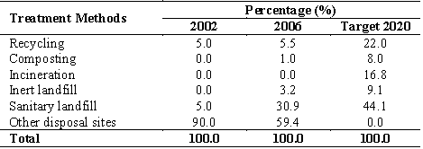

Source: (Samsudin and Don, 2013)

Life Tree is inspired by another tower defence game titled Defender II. Life Tree is built on XNA and originally founded by Althen and his teammates to join windows Imagine Cup. After the competition, the game passed to us for conversion and extension. However they took agile method, hence there is no documentation on Life Tree. After studied through their codes, the game engine used is incompatible with Android platform. We ended up using another game engine and algorithm to make it work on the Android platform. Only some the resources (images and sounds) are reused in this project.

**Problem Statement**

Pollution has accompanied man for decades, however not many action is taken mitigate the pollution at hand. One of the reason is that people lack of the knowledge to solve this matter.

In previous attempts, cartoons is imposed to raise awareness about pollution to young generations via television. Perhaps the most popular of these is to teach youngsters in their early education. Unfortunately these attempts seems to have filed to raise public awareness regarding pollution.

Earth is dying due to this pollutions. Action is needed so as our Earth is to remain clean and safe to life in for all species.

**Objectives**

* To increase the awareness of pollution.
* Help to decrease / maintain the air pollution index (API) between 0 – 50.
* Help to increase / maintain the water quality index (WQI) between 80 – 100.
* Help to maintain the noise pollution between 55dB – 70dB within residential area.
* Help to reduce / maintain the numbers of solid waste to 30,000 tons before 2020.
* Help to increase percentage the waste treatment methods by using recycle to 22% in 2020.
* To promote the 3R (Reduce, Reuse, Recycle) concept to citizens.

**Scope**

This game only supports Android-powered smartphones/tablets (v4.0 and above) and optimized for screen resolution of 800x480. Its user interface includes shop to buy items, setting scene, world/level selection scene, gameplay scene, pause scene, game complete scene, and game over scene, and tutorial scene.

**Task allocation**

|  |  |
| --- | --- |
| Roles | Member |
| Team Leader | Chai Min Chun |
| Development Manager | Lai Ted Liang |
| Planning Manager | Choo Ting Wei |
| Quality Manager | Willis Fung Shin Choi |
| Test Manager | Lim Ban Yong |
| Support Manager | Lim Ban Yong |
| Process Manager | Willis Fung Shin Choi |

**Project Goal**

**Reducing the negative impact of environment pollution such as air pollution, noise pollution, water pollution, and solid waste. Promote the 3R (Reduce, Reuse, Recycle) concept to citizens by using interesting android game.**

**Team Goal**

**Team Goal 1 : Develop a high quality product.**

* **Range of defect found before 1st compile in percentage: 70% - 80%.**
* **Defect identified during test: < 3.**
* **Percentage of project requirement that achieved after completion: 100%.**

**Team Goal 2 : Create a productive and well-managed on project documentation.**

* **Percentage of documentation completion: 100%.**
* **Error in predicting project’s product size: < 15%.**
* **Error in predicting project’s development hours: < 15%.**

**Team Goal 3 : Finish all the task according to gantt chart.**

* **Days early or late in completing a specific task: < 2.**

**Team Contribution**

|  |  |
| --- | --- |
| Team Leader | * Lead project team towards the same goal * Delegate tasks and monitor team members’ work flow * Be responsible for any preparation that team members required * Pay attention to team members’ feedback |
| Development Manager | * Show developed results to customer to ensure the software always meet customers’ requirement. * Manage the development team to work efficiently |
| Planning Manager | * Monitor every department expenses * Assist team members to manage all production schedules * Arrange well-organized training programs for all planning processes * Cooperate with all stakeholders to come out with a different strategy |
| Quality Manager | * Ensure project achieves the project goal * Advise the performance of quality management system * Ensure project meets customer requirement |
| Test Manager | * Confirm the suitable planning and management of the test effort * Evaluate the progress and efficiency of the test effort * Discuss the deliverables of the test effort |
| Support Manager | * Manage technical and information system * Manage the maintenance and security issues * Supervise the performance of team members and the system |
| Process Manager | * Assist team to review current processes for efficiency * Improve operational effectiveness * Produce process workflow |

**Expected Result**

1. Outputs – Runnable android game.

2. Outcomes – Able to deliver the message that our environment is sick and action needed to be taken to overcome the effect of the pollution.

3. Impact – Environment thought is implanted.

**Checklist**

|  |  |  |
| --- | --- | --- |
| **Features** | **Defender II** | **Life Tree** |
| Straight-line projectile |  |  |
| Bounce projectile (within boundary) |  |  |
| World selection |  |  |
| Level selection |  |  |
| Skills |  |  |
| Shop |  |  |
| Monster take damage upon hit and attribute |  |  |
| Story |  |  |
| Mix of attributes |  |  |

Sample screenshot(left: Defender II; right; Life Tree)

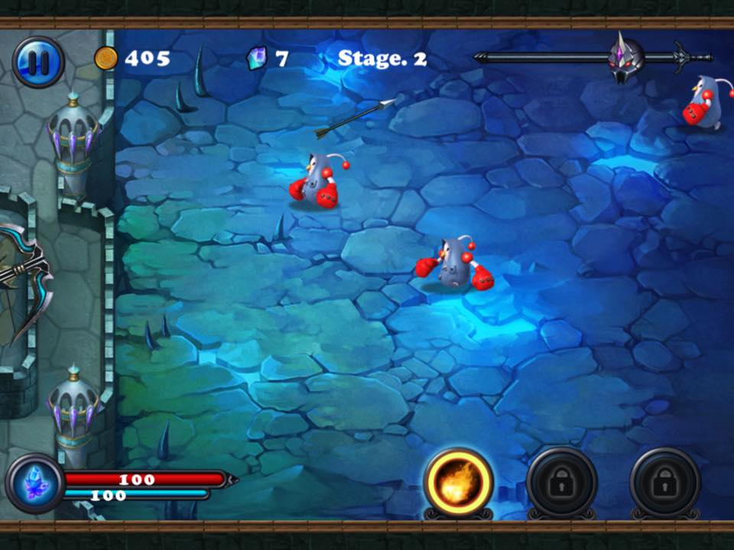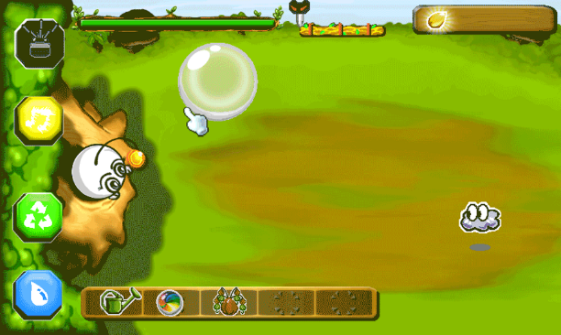

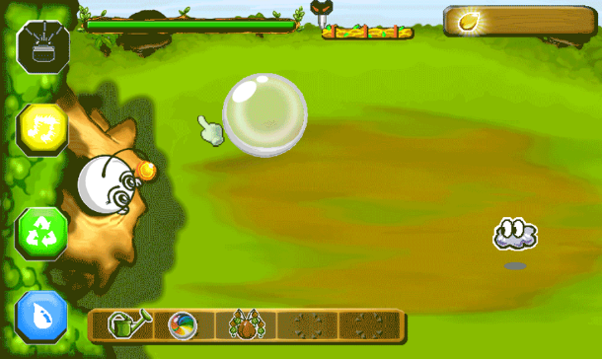

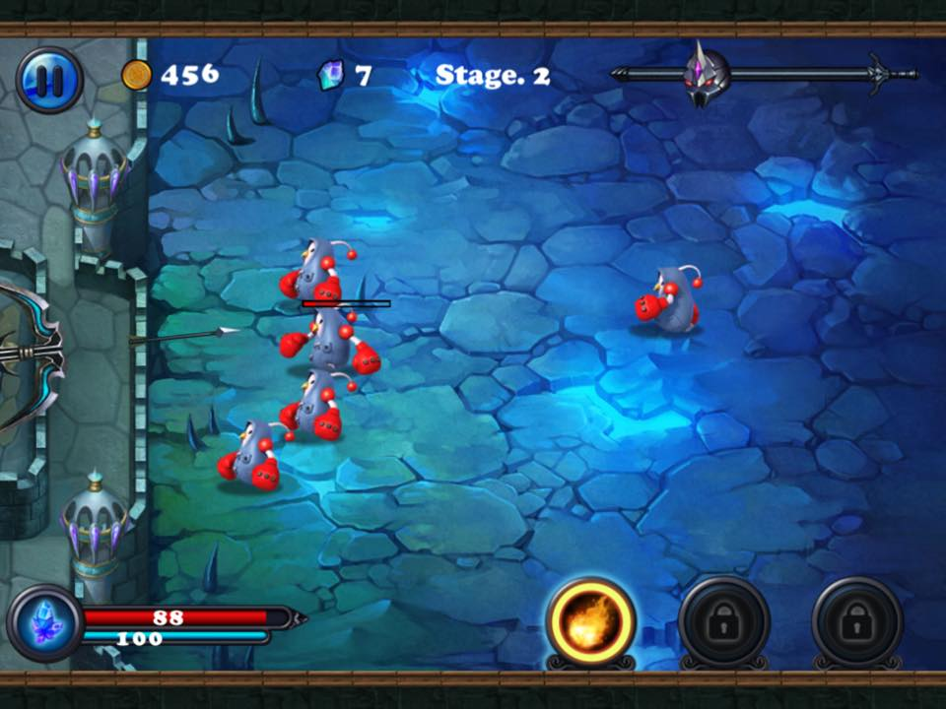

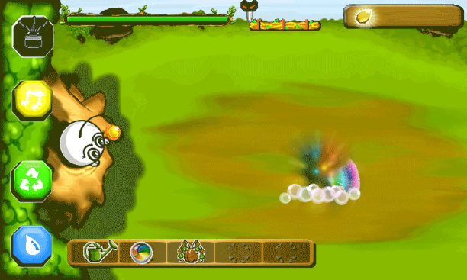

**Project Planning**

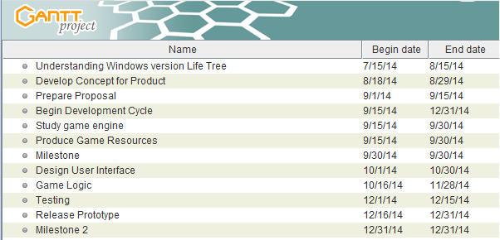

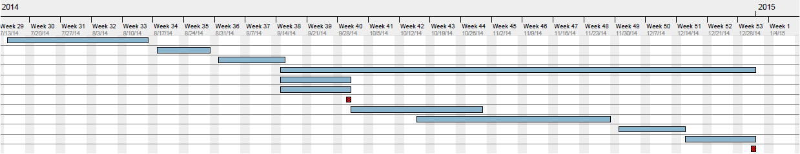

TSP Student Information Sheet: Form Info

Name: Chai Min Chun Instructor: Mdm Nurfauza Jali

Date : Number of College Credits:

Major: Software Engineering Expected Graduation Date: 2016

Briefly describe your relevant experience and interests:

- One year experiences in android application development.

- Able to use Photoshop.

- Able to create website application.

- Can speak English, Malay and Chinese.

- Interest in application development.

- Interest in graphic design.

- Interest in game programming.

Briefly describe your work on other team projects:

Programmer.

Briefly describe any leadership or management positions you have held (at work or in clubs/ organization):

_________________________________________________________________________________________________________________________________________________________________________________________________________________________________________________________________________________________________________________________________________________________________________________________________________________________________________

State your team preferences, if any:

____________________________________________________________________________________________________________________________________________________________________________________________________________________________________________________________________________________________________________________________________________________

|  |  |  |  |  |  |  |  |
| --- | --- | --- | --- | --- | --- | --- | --- |
| **List your class schedule and other times when you have scheduled activities such as work ,clubs, sports teams, etc.** | | | | | | | |
| Time | Mon | Tues | Wed | Thurs | Fri | Sat | Sun |
| 0800-0845 |  |  | Lecture |  | Lecture |  |  |
| 0900-0945 | Lecture |  | Lecture |  | Lecture |  |  |
| 1000-1045 | Lecture |  | Lecture |  | Lecture |  |  |
| 1100-1145 |  |  | Lecture | Lecture | Lecture |  |  |
| 1200-1245 |  |  | Lecture | Lecture |  |  |  |
| 1300-1345 |  |  |  |  |  |  |  |
| 1400-1445 | Lecture |  |  |  | Lecture |  |  |
| 1500-1545 | Lecture |  |  |  | Lecture |  |  |
| 1600-1645 | Lecture |  |  |  | Lecture |  |  |
| 1700-1745 |  |  |  |  |  |  |  |
|  |  |  |  |  |  |  |  |

|  |
| --- |
| Rank from 1 (least) to 5 (most) your preferences for serving in the following team roles: |
| Team Leader 1 2 3 4 5 |
| Development Manager 1 2 3 4 5 |
| Planning Manager 1 2 3 4 5 |
| Quality/Process Manager 1 2 3 4 5 |
| Support Manager 1 2 3 4 5 |

TSP Student Information Sheet: Form Info

Name : Choo Ting Wei (36579) ____________ Instructor: Mdm Nurfauza Jali

Date : _____________________________________ Number of College Credits :

Major : Software Engineering____________________ Expected Graduation Date : 2016

Briefly describe your relevant experience and interests:

* Developed a simple mini games in OpenGL programming language using MinGW.
* Interest in games that require player’s skill and reflex.
* Interested in game development.

Briefly describe your work on other team projects:

* Programmer in Computer Graphics using MinGW.
* Programmer in Multimedia Programming using JAVA.

Briefly describe any leadership or management positions you have held (at work or in clubs/ organization):

-

State your team preferences, if any:

____________________________________________________________________________________________________________________________________________________________________________________________________________________________________________________________________________________________________________________________________________________

|  |  |  |  |  |  |  |  |
| --- | --- | --- | --- | --- | --- | --- | --- |
| **List your class schedule and other times when you have scheduled activities such as work ,clubs, sports teams, etc.** | | | | | | | |
| Time | Mon | Tues | Wed | Thurs | Fri | Sat | Sun |
| 0800-0845 |  |  | Lecture |  | Lecture |  |  |
| 0900-0945 | Lecture |  | Lecture |  | Lecture |  |  |
| 1000-1045 | Lecture |  | Lecture |  | Lecture |  |  |
| 1100-1145 |  |  | Lecture | Lecture | Lecture |  |  |
| 1200-1245 |  |  | Lecture | Lecture |  |  |  |
| 1300-1345 |  |  |  |  |  |  |  |
| 1400-1445 | Lecture |  |  |  | Lecture |  |  |
| 1500-1545 | Lecture |  |  |  | Lecture |  |  |
| 1600-1645 | Lecture |  | Sports |  | Lecture |  |  |
| 1700-1745 |  |  | Sports |  | Sports |  |  |
|  |  |  |  |  |  |  |  |

|  |
| --- |
| Rank from 1 (least) to 5 (most) your preferences for serving in the following team roles: |
| Team Leader 1 2 3 4 5 |
| Development Manager 1 2 3 4 5 |
| Planning Manager 1 2 3 4 5 |
| Quality/Process Manager 1 2 3 4 5 |
| Support Manager 1 2 3 4 5 |

TSP Student Information Sheet: Form Info

Name: Lai Ted Liang Instructor: Mdm Nurfauza Jali

Date : 04/10/14 Number of College Credits:

Major: Software Engineering Expected Graduation Date: 06/22/16

Briefly describe your relevant experience and interests:

I like programming. I’ve attended an android workshop on year 2013 during long semester break. I’ve collaborated with few of my friends to give android training this year.

Briefly describe your work on other team projects:

Built/made databases using mysql and ms access, websites, android web apps, android calculator, and java paint application, documentations, presentation slides.

Briefly describe any leadership or management positions you have held (at work or in clubs/ organization):

_________________________________________________________________________________________________________________________________________________________________________________________________________________________________________________________________________________________________________________________________________________________________________________________________________________________________________

State your team preferences, if any:

____________________________________________________________________________________________________________________________________________________________________________________________________________________________________________________________________________________________________________________________________________________

|  |  |  |  |  |  |  |  |
| --- | --- | --- | --- | --- | --- | --- | --- |
| **List your class schedule and other times when you have scheduled activities such as work ,clubs, sports teams, etc.** | | | | | | | |
| Time | Mon | Tues | Wed | Thurs | Fri | Sat | Sun |
| 0800-0845 |  |  | Lecture |  | Lecture |  |  |
| 0900-0945 | Lecture |  | Lecture |  | Lecture |  |  |
| 1000-1045 | Lecture |  | Lecture |  | Lecture |  |  |
| 1100-1145 |  | Lecture | Lecture | Lecture | Lecture |  |  |
| 1200-1245 |  | Lecture | Lecture | Lecture |  |  |  |
| 1300-1345 |  | Lecture |  |  |  | Lecture |  |
| 1400-1445 | Lecture |  |  |  | Lecture | Lecture |  |
| 1500-1545 | Lecture |  |  |  | Lecture |  |  |
| 1600-1645 | Lecture |  | Sports |  | Lecture |  |  |
| 1700-1745 |  |  | Sports |  | Sports |  |  |
|  |  |  |  |  |  |  |  |

|  |
| --- |
| Rank from 1 (least) to 5 (most) your preferences for serving in the following team roles: |
| Team Leader 1 2 3 4 5 |
| Development Manager 1 2 3 4 5 |
| Planning Manager 1 2 3 4 5 |
| Quality/Process Manager 1 2 3 4 5 |
| Support Manager 1 2 3 4 5 |

TSP Student Information Sheet: Form Info

Name : Lim Ban Yong (36709) ____________ Instructor: Mdm Nurfauza Jali

Date : _____________________________________ Number of College Credits : -

Major : Software Engineering____________________ Expected Graduation Date : 2016_

Briefly describe your relevant experience and interests:

* Created a web based mobile application.
* Interested in develop a games in android.
* Interested in software testing and identify test cases.

Briefly describe your work on other team projects:

* Built a database system using Microsoft Access and mySQL.
* Built a website and web based mobile application using javascript, HTML, CSS, JQuery mobile, and PHP.
* Prepared documentation.

Briefly describe any leadership or management positions you have held (at work or in clubs/ organization):

-

State your team preferences, if any:

____________________________________________________________________________________________________________________________________________________________________________________________________________________________________________________________________________________________________________________________________________________

|  |  |  |  |  |  |  |  |
| --- | --- | --- | --- | --- | --- | --- | --- |
| **List your class schedule and other times when you have scheduled activities such as work ,clubs, sports teams, etc.** | | | | | | | |
| Time | Mon | Tues | Wed | Thurs | Fri | Sat | Sun |
| 0800-0845 |  |  | Lecture |  | Lecture |  |  |
| 0900-0945 | Lecture | Lab | Lecture |  | Lecture |  |  |
| 1000-1045 | Lecture | Lab | Lecture | Lecture | Lecture |  |  |
| 1100-1145 |  | Lecture | Lecture | Lecture | Lecture |  |  |
| 1200-1245 |  | Lecture | Lecture |  |  |  |  |
| 1300-1345 |  |  |  |  |  |  |  |
| 1400-1445 | Lecture |  |  | Lecture | Lecture |  |  |
| 1500-1545 | Lecture |  |  |  | Lecture |  |  |
| 1600-1645 | Lecture |  |  |  | Lecture |  |  |
| 1700-1745 |  |  | Sports |  | Sports |  | Sports |
|  |  |  |  |  |  |  |  |

|  |
| --- |
| Rank from 1 (least) to 5 (most) your preferences for serving in the following team roles: |
| Team Leader 1 2 3 4 5 |
| Development Manager 1 2 3 4 5 |
| Planning Manager 1 2 3 4 5 |
| Quality/Process Manager 1 2 3 4 5 |
| Support Manager 1 2 3 4 5 |

TSP Student Information Sheet: Form Info

Name : Willis Fung Shin Choi_(39324)_____________ Instructor: Mdm Nurfauza Jali

Date : _____________________________________ Number of College Credits : -

Major : Software Engineering____________________ Expected Graduation Date : 2016

Briefly describe your relevant experience and interests:

* Collaborated with colleagues to give Android training to our juniors.
* Tested and restructured codes for easy debugging and understanding.
* Fluent in English, conversational ability in Malay and English.
* Computer skills: Mathematics, Microsoft Office, C, C++, JAVA, Prolog, Android SDK.
* Interested in game development.

Briefly describe your work on other team projects:

* Programmer in Logic Programming using WIN Prolog.
* Programmer in Expert Systems using WIN Prolog.

Briefly describe any leadership or management positions you have held (at work or in clubs/ organization):

-

State your team preferences, if any:

____________________________________________________________________________________________________________________________________________________________________________________________________________________________________________________________________________________________________________________________________________________

|  |  |  |  |  |  |  |  |
| --- | --- | --- | --- | --- | --- | --- | --- |
| **List your class schedule and other times when you have scheduled activities such as work ,clubs, sports teams, etc.** | | | | | | | |
| Time | Mon | Tues | Wed | Thurs | Fri | Sat | Sun |
| 0800-0845 |  |  | Lecture |  | Lecture |  |  |
| 0900-0945 | Lecture |  | Lecture |  | Lecture |  |  |
| 1000-1045 | Lecture |  | Lecture |  | Lecture |  |  |
| 1100-1145 |  |  | Lecture | Lecture | Lecture |  |  |
| 1200-1245 |  |  | Lecture | Lecture |  |  |  |
| 1300-1345 |  |  |  |  |  |  |  |
| 1400-1445 | Lecture |  |  |  | Lecture |  |  |
| 1500-1545 | Lecture |  |  |  | Lecture |  |  |
| 1600-1645 | Lecture |  | Sports |  | Lecture |  |  |
| 1700-1745 |  |  | Sports |  | Sports |  |  |
|  |  |  |  |  |  |  |  |

|  |
| --- |
| Rank from 1 (least) to 5 (most) your preferences for serving in the following team roles: |
| Team Leader 1 2 3 4 5 |
| Development Manager 1 2 3 4 5 |
| Planning Manager 1 2 3 4 5 |
| Quality/Process Manager 1 2 3 4 5 |
| Support Manager 1 2 3 4 5 |

**References**

2012 solid waste exceeds projected production in 2020. (2013). *BorneoPost Online*. Retrieved October 3, 2014, from <http://www.theborneopost.com/2013/08/27/2012-solid-waste-exceeds-projected-production-in-2020/>

Air Quality Index (AQI) - A Guide to Air Quality and Your Health. (2014). *AirNow*. Retrieved

October 3, 2014, from <http://airnow.gov/index.cfm?action=aqibasics.aqi>.

Chernobyl Accident 1986. (n.d.). *World Nuclear Association*. Retrieved October 2, 2014, from <http://www.world-nuclear.org/info/Safety-and-Security/Safety-of-Plants/Chernobyl-Accident/>.

Hossain, M.A., Sujaul, L.M., & Nasly, M.A. (2013). Water Quality Index: an Indicator of Surface Water Pollution in Eastern part of Peninsular Malaysia. *Research Journal of Recent Sciences*, 2(10), 10-17. Retrieved October 3, 2014, from [www.isca.in/rjrs/archive/v2/i10/3.ISCA-RJRS-2013-171.pdf](http://www.isca.in/rjrs/archive/v2/i10/3.ISCA-RJRS-2013-171.pdf).

How much decibel is acceptable to human body?. (n.d.). *Answers*. Retrieved October 3, 2014, from <http://www.answers.com/Q/How_much_de>.

Nurul, H.A. (2014, May 19). Perhebat amalan konsep 3R. *Utusan Online.* Retrieved from <http://www.utusan.com.my/utusan/Impak_Alam/20140519/al_01/Perhebat-amalan-konsep-3R>.

Samsudin, M.D.M., & Don, M.M. (2013). Municipal Solid Waste Management in Malaysia: Current Practices, Challenges and Prospect [Electronic version]. *Jurnal Teknologi,* 62(1), 3-4.